ISSACK WAITHAKA
cs-sa07-24085

Introduction
- This is the analysis of data and information using tools and techniques to generate meaningful patterns on how to mitigate against potential risks.
- Its classification include strategic intel, Technical intel, Tactical Intel, Operational Intel

UrlScan.io
- It is a service developed to assist in scanning and analyzing websites.
- It records domains, ips, resources requested from the domains, a snap shot of the page, etc, when a url is submitted

Questions
1.
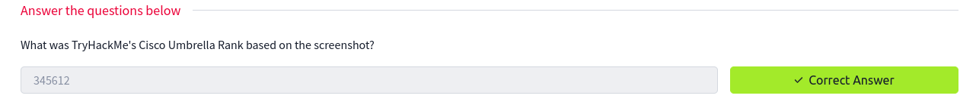
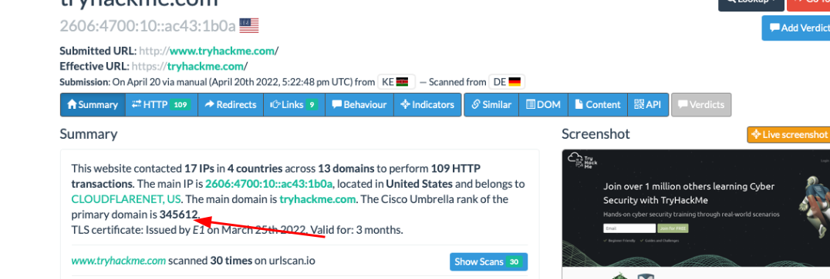
2.
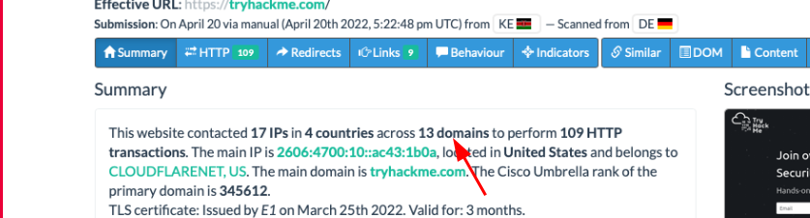
3.
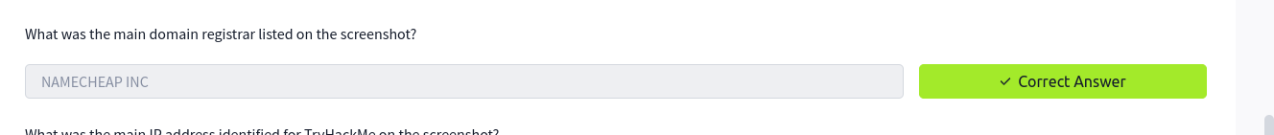
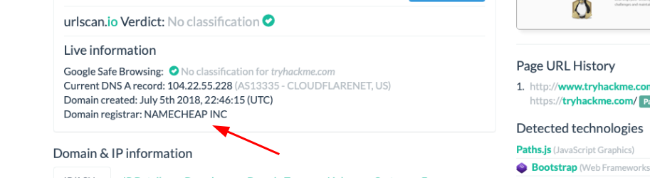
4.
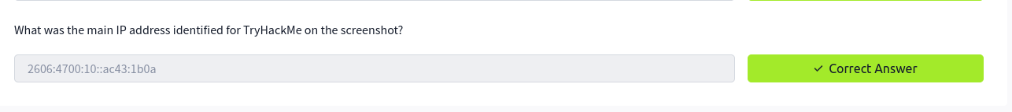
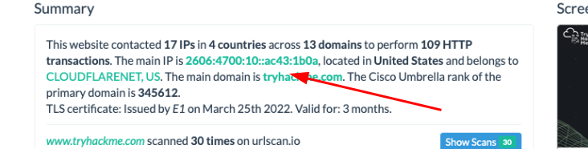

Abuse.ch
- This is a research project that was developed to identify and track malware and botnets through several operational platforms.
- The platforms include:
= MalwareBazaar which is a malware collection and analysis database
= FeodoTracker which Provide database of the c&c servers that security analysts can through and investigate suspicious IP
= SSL blacklist – used to detect and identify malicious ssl connections
= URLhaus – share malicious urls used for malware distribution
= ThreatFox security analyst can use this tool to search, share and exploit indicators of compromise associated with malware

Questions
1.
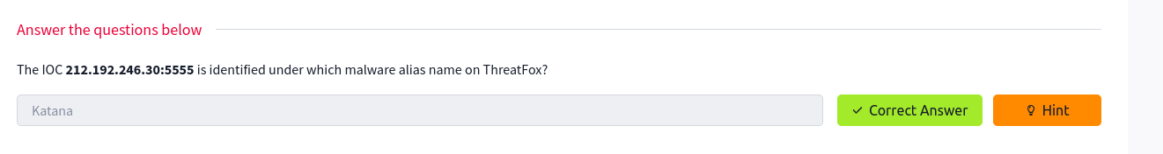
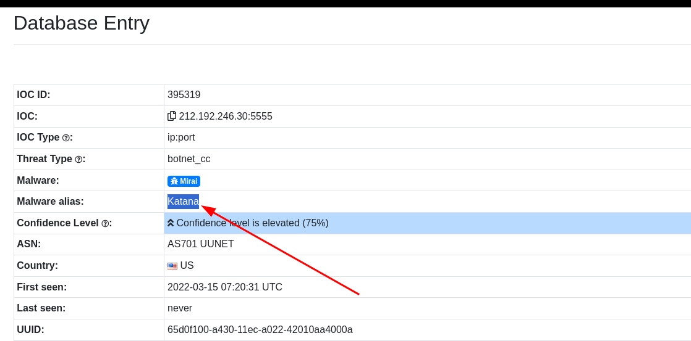
2.
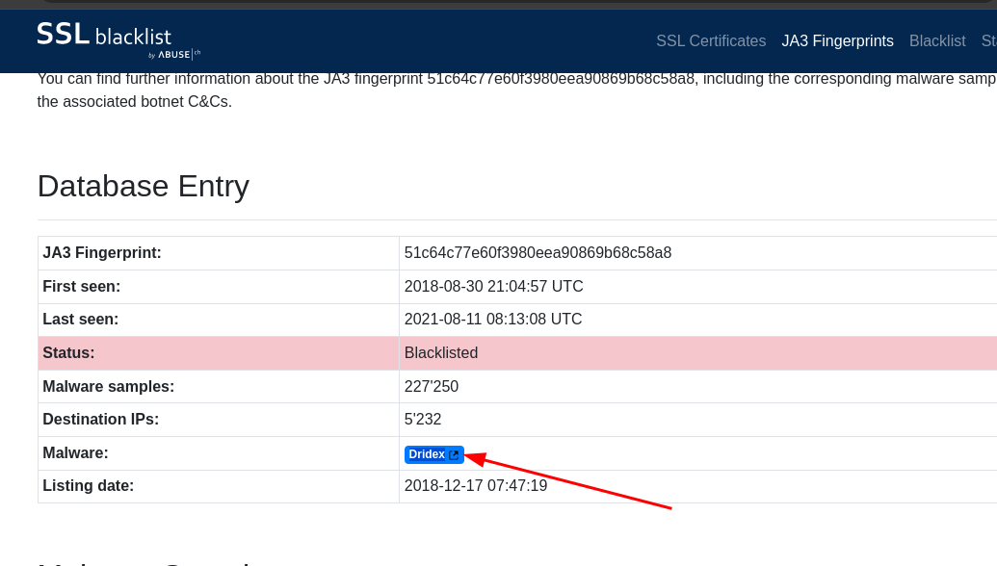
3.
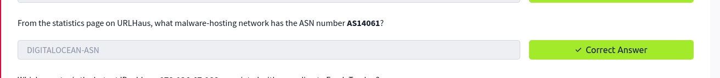
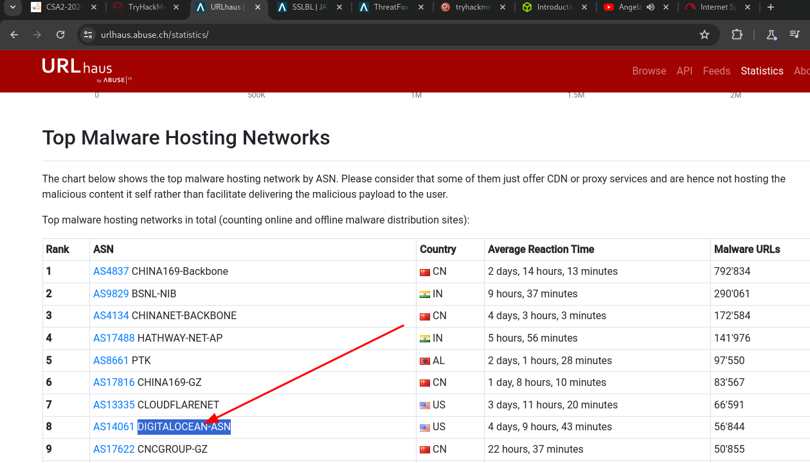

4.
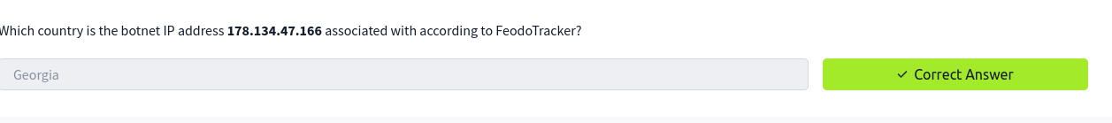
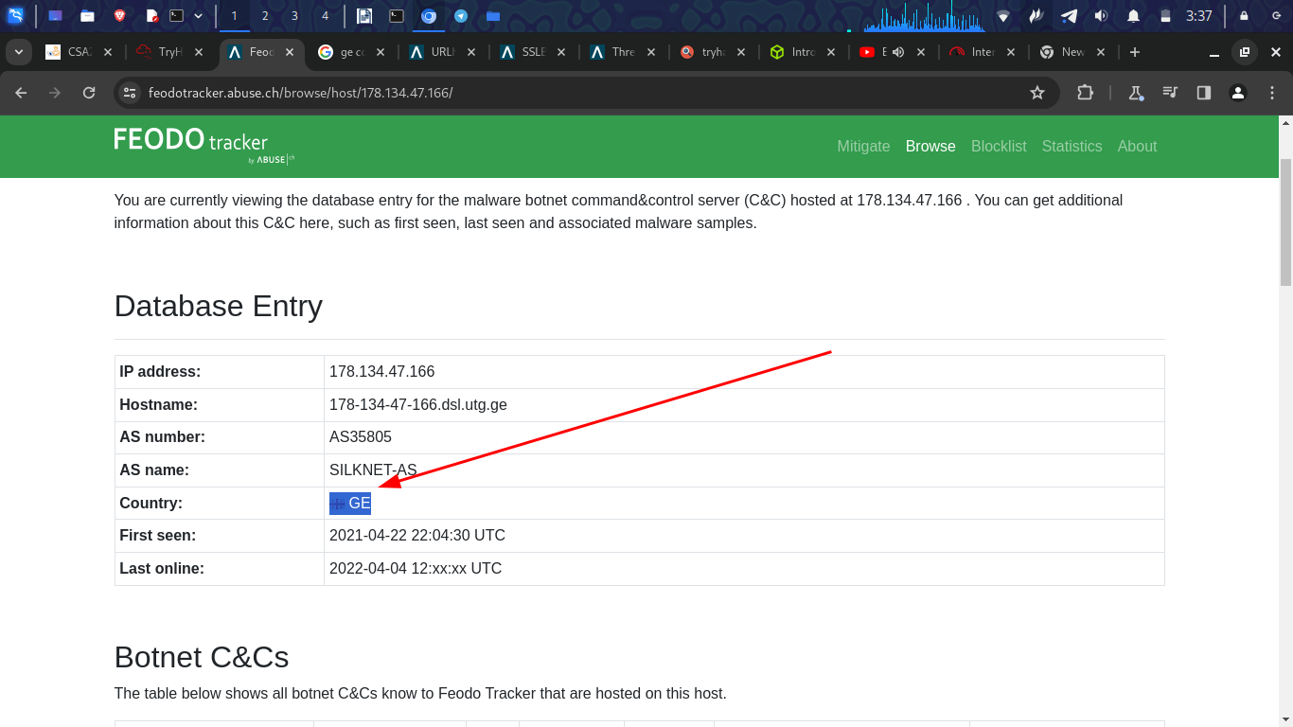

Email Phishing
- Unsuspecting users get dumped into opening and accessing malicious files sent to them via email.
- It perform email analysis: It retrieves metadata from phishing emails
- Heuristic intelligence: provide analysts with the intelligence needed to stay ahead of persistent attacks
- classification and reporting this allows analysts to take action quickly

Questions
1.
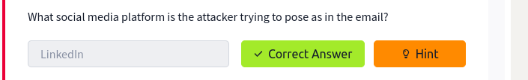
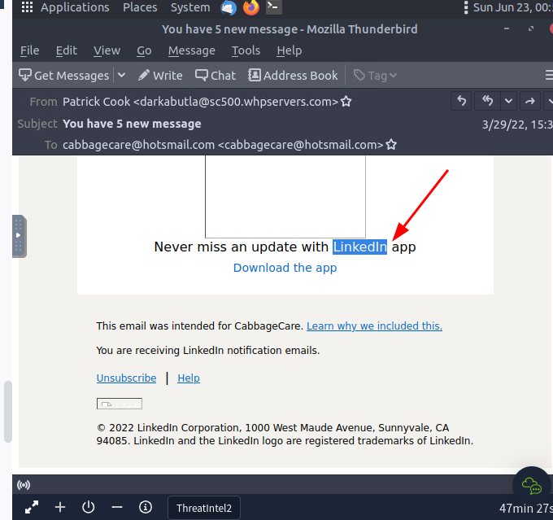

2.
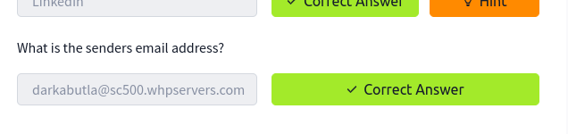
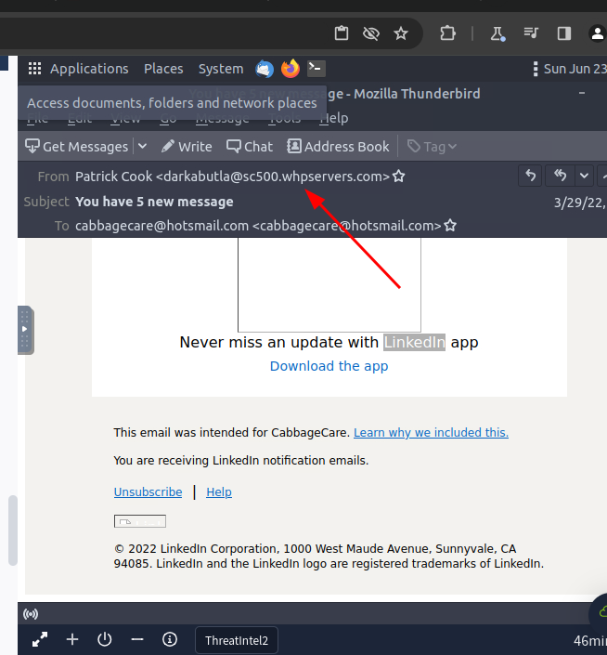

3.
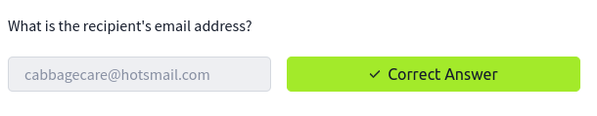
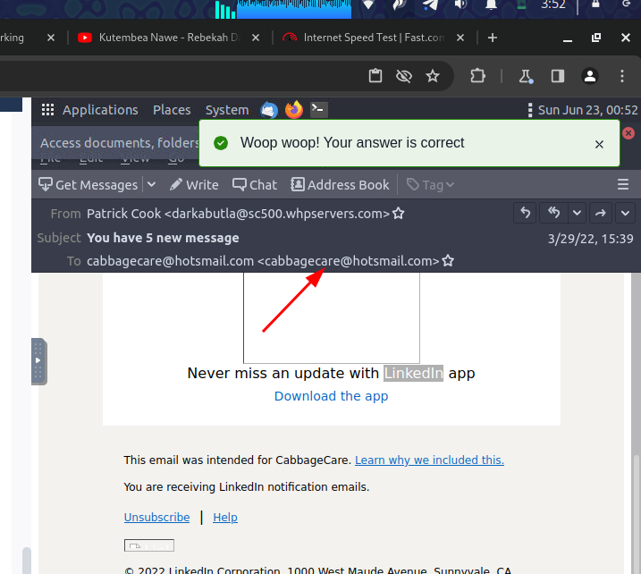

4.
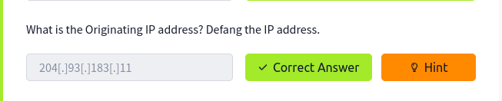
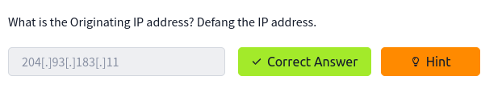
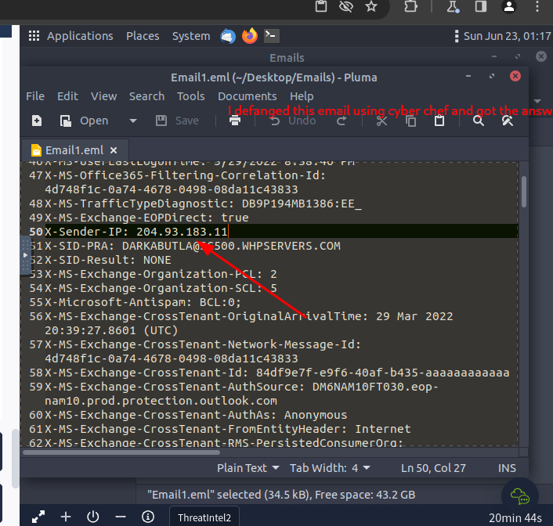

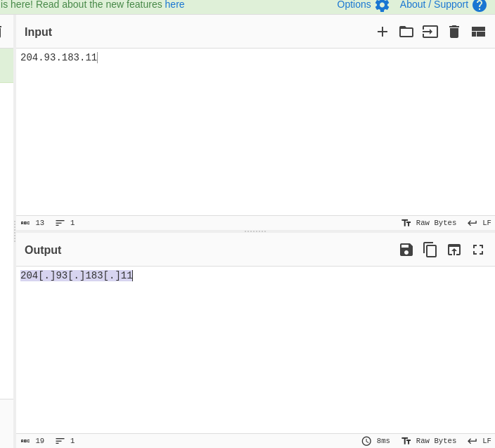

5.
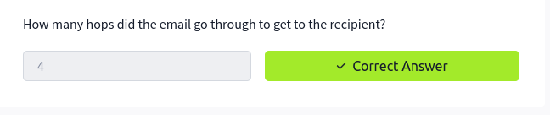
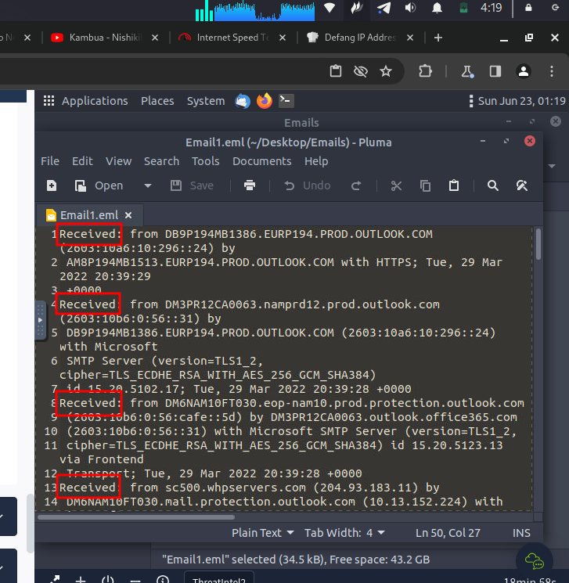

Cisco Talos Intelligence
- A team in cisco to provide actionable intelligence, visibility on indicators and protection against emerging threats through data collected

Questions
1.
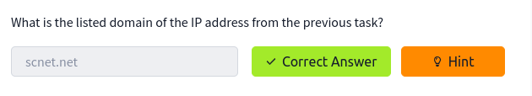
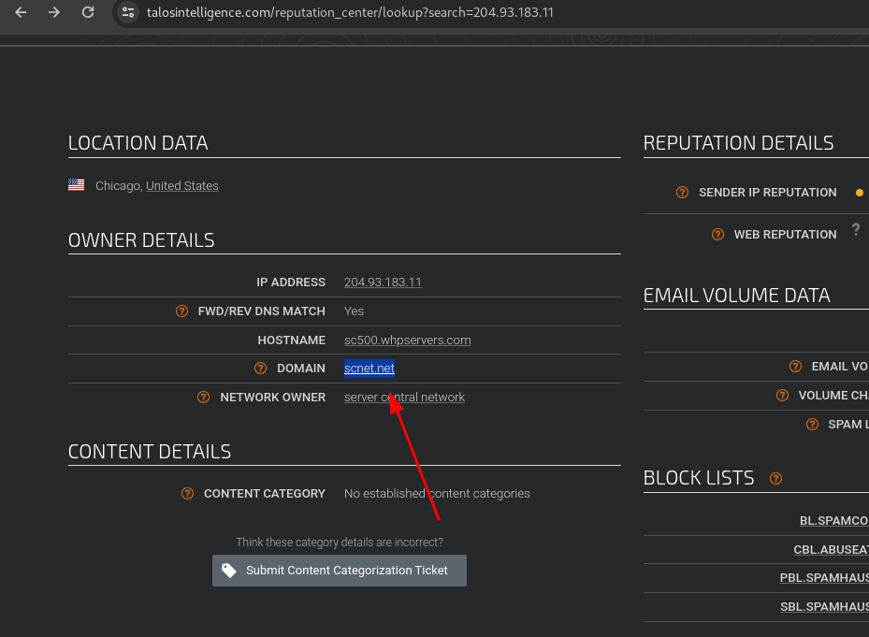

2.
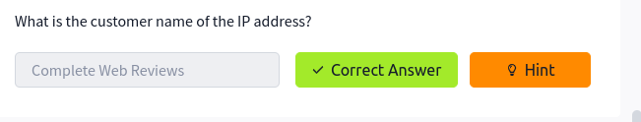
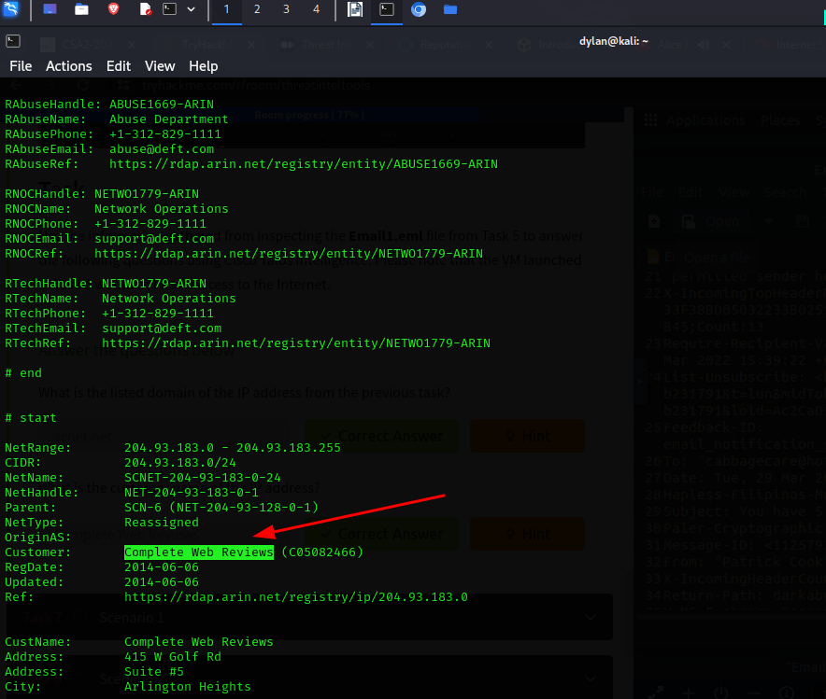

Scenario 1
1.
I opened the email using Thunderbird and got the senders email
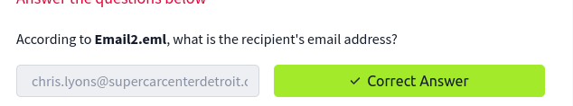
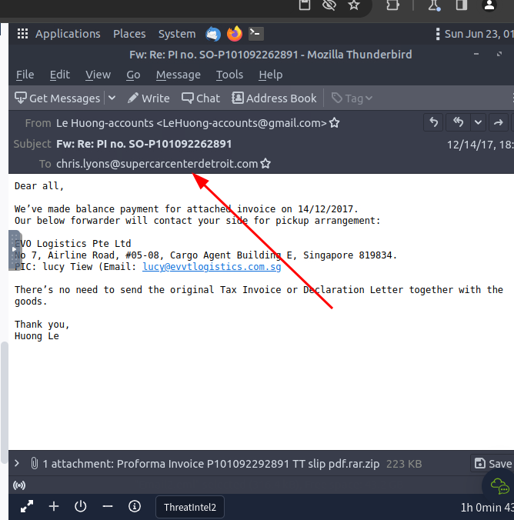
2.
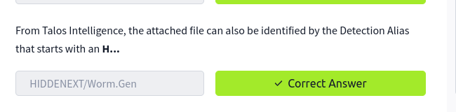
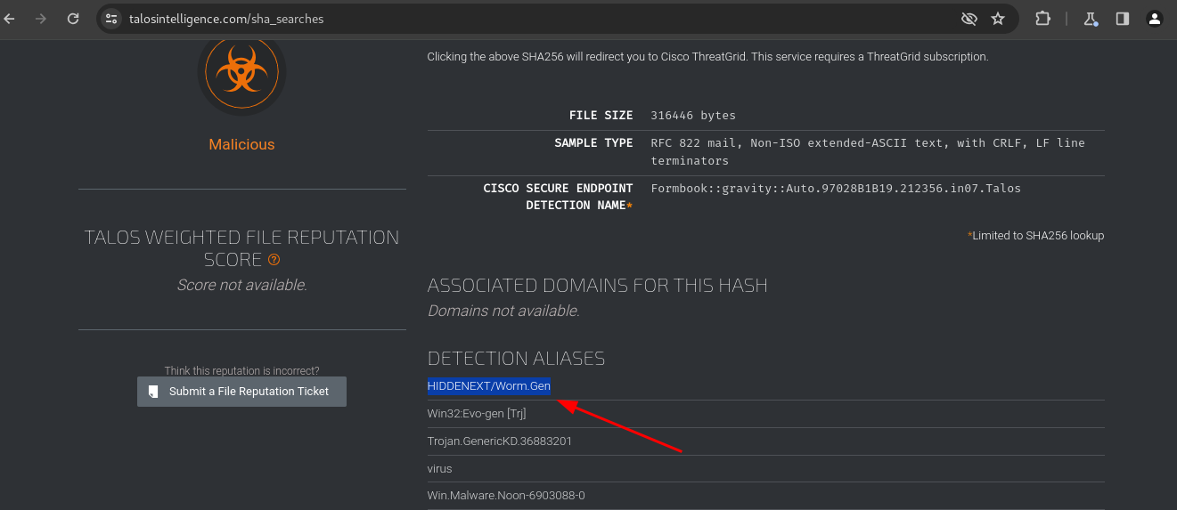

Scenario 2
1.
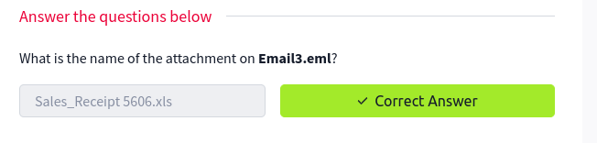
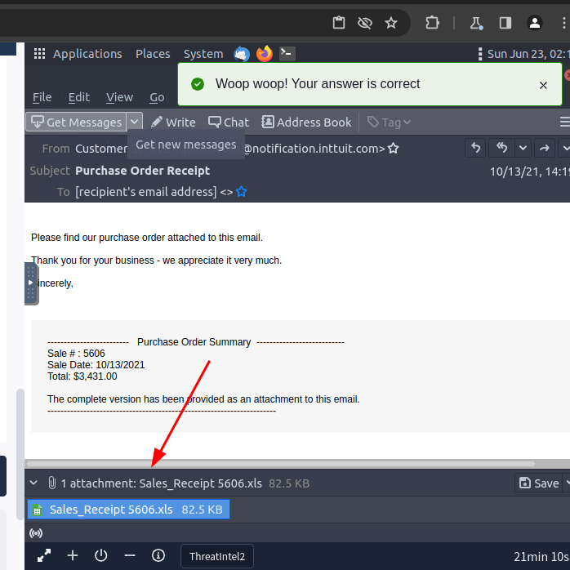
2
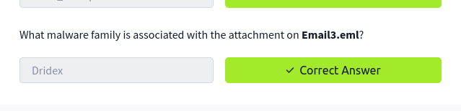
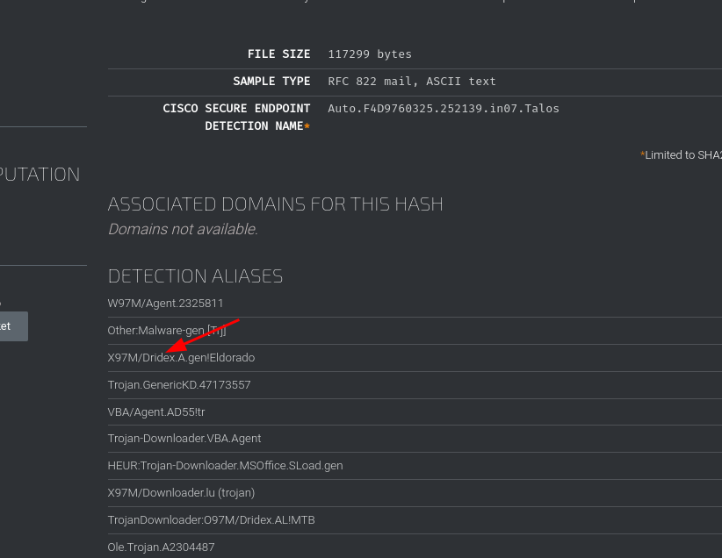
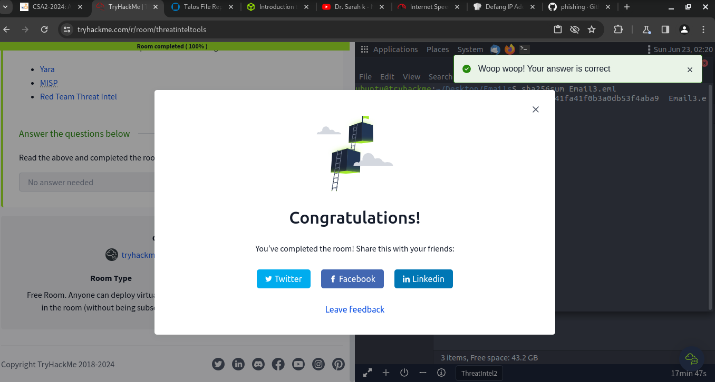

Conclusion
In this room I went through a couple of tools that are used for threat intelligence. I have also learnt how to use them. I am looking forward to learn more threat intelligence tools.

